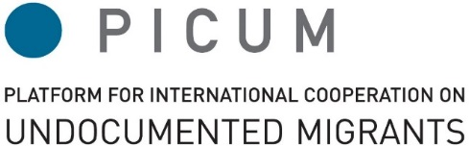
#GA2018
@PICUM_post

PICUM General Assembly
20 – 21 April 2018
The International Auditorium
Boulevard Roi Albert II 5, 1210 Brussels

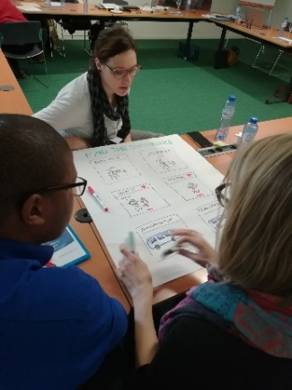
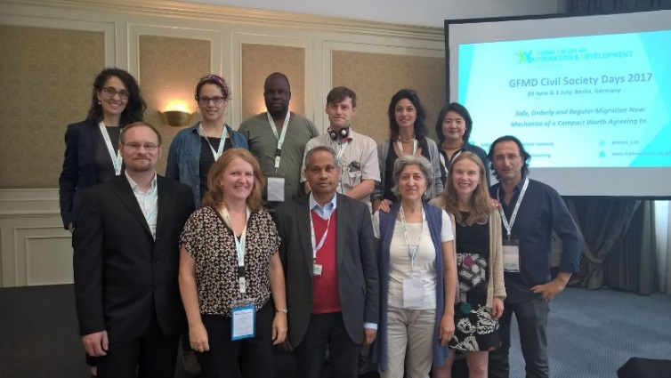
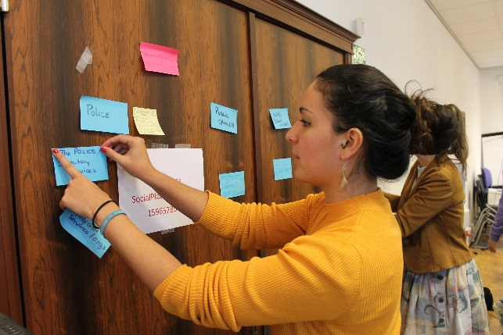

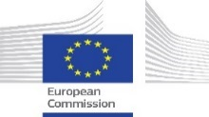
This event was made possible with kind support from
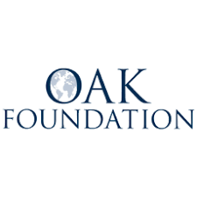
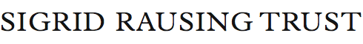
With financial support
from the European Union
Supported by a grant from the Open Society Initiative
for Europe of the Open Society Foundations

PICUM General Assembly

PICUM's General Assembly is the main decision-making body of the network. Meeting in Brussels, PICUM members come together to engage, strategize and mobilise to improve the situation of undocumented migrants across Europe and beyond.

The General Assembly is a key part of PICUM's annual calendar. It provides an important opportunity for members to mobilise around key issues, engage policy makers, develop strategies, and steer the direction of the PICUM network.

PICUM members vote and work together to shape the network’s response, ensure effective governance, and admit new organisations.

Held over two days, the General Assembly provides opportunities for collaboration and exchange and fosters members’ engagement and ownership of the network. Members can build partnerships and gain vital insights on the situation facing undocumented migrants at local, national, EU and global level.

The 2018 General Assembly will be an interactive event including:

- An expert panel discussion on recent migration policy developments
- Thematic break-out sessions
- A series of training sessions
- An opportunity for members to host a ‘Floor is Yours’ session.

At this year’s General Assembly, PICUM members can:
- Develop a common understanding regarding recent migration policy developments, how they impact the network, and shape PICUM's response;
- Learn more about PICUM's strategic objectives on:
  - Access to Healthcare
  - Fair Working Conditions
  - Access to Justice;
  - Undocumented Children and Families;
  - Detention and Return
- Support and highlight positive developments and responses developed by the PICUM network;
- Connect, share lessons learned, exchange practical information and develop partnerships with fellow advocates working across Europe as well as globally.

PICUM General Assembly 2018
DAY 1 ⏐ Friday 20 April 2018 ⏐ 9:00 – 18:15
8:30 – 9:00 | Registration and coffee
OPENING PLENARY
9:00 – 9:15 | Intro and welcome  Edel McGinley, PICUM Chair and Director, Migrants Rights Center Ireland
9:15 – 9:45 | Narrative, story-telling exercise / member engagement  Support sharing of members’ experiences
9:45 – 10:30 | PANEL DISCUSSION ‘Supporting change’  Chair: Jan Knockaert, Director, Fair Work Belgium  Monami Maulik, Coordinator, Global Coalition of Migration  Heather Grabbe, Director, Open Society European Policy Institute
10:30 – 11:00 | Coffee break and Group Picture
11:00 – 12:30 | Capacity Building Workshops
- Communicating on human rights
Facilitator: Thomas Coombes, Head of Brand & Deputy Communications Director, Amnesty International
Languages: English - Spanish
A communications professional will share some of latest research on human rights communication, and the importance of emotions when trying to influence audiences. The workshop will also address the importance of message framing and share some research findings on communications concerning migrants and refugees. The session also aims to explain the need for organisations to be able to talk about their vision for the world.
- Measuring your impact to support funding applications
Facilitator: Caroline Gardner, CEO, Quality Matters
Language: English
This workshop will cover the basics steps of measuring outcomes. It will cover setting up an outcome measurement framework (logic model) and selecting good outcome tools. Participants will get a small pack which includes a number of useful validated outcome tools in the area of social inclusion and integration, as well as how to maximise the story the data should tell. The workshop will review good outcome measures for a range of services types, from drop-in and information services to professional training courses, to case management key working and advocacy services.

- Engaging pro-bono support
Facilitator: Anna Duron, Ashurst, Lamin Khadar, DLA and Giacomo Delinavelli, The Good Lobby
Language: English
In this workshop, experts will provide insight on the variety of ways that law firms can provide pro bono support, and share good practices on collaboration between pro bono law firms and NGOs. Members will have the opportunity to share and discuss their experiences seeking and obtaining pro bono legal support, and explore strategies to effectively engage with pro bono lawyers on the rights of undocumented migrants, including in countries with limited pro bono culture.
- Generating data for advocacy
Facilitator: Nathalie Simonnot, General Delegate on Partnerships, Médecins du Monde
Languages: English - French
Medecins du Monde has collected data since 2005 from undocumented patients visiting its clinics throughout Europe and synthesized this in annual reports highlighting gaps in health care for populations facing vulnerabilities. Drawing on this experience, this workshop will explore how organizations can collect quantitative and qualitative data to advocate for undocumented migrants. Participants will explore how to develop more substantial evidence bases about a wide range of issues undocumented migrants are confronted with. NB: Participants who already collect data, please send the questionnaires you use to collect data to Nathalie at least 10 days in advance so the workshop can build on everybody's experience (nathalie.simonnot@medecinsdumonde.net).
- General Data Protection Regulation (GDPR): How can you comply?
Facilitator: Jan-Frederik Keustermans, Lawyer, Cleary Gottlieb Steen and Hamilton LLP
Languages: English - Spanish
Data protection and contact management can be complex but it matters how we treat personal information of migrants and refugees whom we work with, our subscribers and target audiences. A new data protection regulation (GDPR) coming into force on 25 May 2018 sets out new rules that any organisation in the EU has to comply with. In this workshop, a lawyer will explain in an easy to understand way what you have to do to ensure your organisation complies with this new regulation.
12:30 – 14:00  13:30 – 14:00 | Lunch  First time participants at GA - Meet and Greet
PLENARY
14:00 – 14:30 | Information about PICUM’s Strategic Plan (2018-2021)  Michele LeVoy, PICUM Director
14:30 – 14:45 | Introduction to Floor is Yours session
BREAK OUT SESSIONS
14:45 – 16:30 | Member Groups: Work Objectives for 2018 (Session A)
Led by PICUM staff, these sessions will enable members to get more information about PICUM’s key objectives in each thematic area and will also provide an opportunity for members to discuss and engage.
- Detention and Return
Facilitator: Kadri Soova, Advocacy Officer
Languages: English – Spanish
- Access to Healthcare
Facilitator: Alyna Smith, Advocacy Officer
Languages: English – French
- Labour Rights
Facilitator: Lilana Keith, Advocacy Officer
Language: English
- Communications
Facilitator: Elisabeth Schmidt-Hieber, Communications Officer
Languages: English – Spanish

16:30 – 16:45 | Break
16:45 – 18:15 | Member Groups: Work Objectives for 2018 (Session B)
Led by PICUM staff, these sessions will enable members to get more information about PICUM’s key objectives in each thematic area and will also provide an opportunity for members to discuss and engage.
- Access to Justice
Facilitator: Alyna Smith, Advocacy Officer
Languages: English – Spanish
- Undocumented Children and their Families
Facilitator: Lilana Keith, Advocacy Officer
Languages: English – French
- UN Global Compact on Migration
Facilitators: Michele LeVoy, Director and Kadri Soova, Advocacy Officer
Languages: English – Spanish
- Communications
Facilitator: Elisabeth Schmidt-Hieber, Communications Officer
Language: English

19:00 – 22:00 | Dinner  Hostel Jacques Brel  Rue de la Sablonnière 30, 1000 Bruxelles

PICUM General Assembly 2018
DAY 2 ⏐ Saturday 21 April 2018 ⏐ 9:00 – 15:15

8:00 – 8:50 | Pre-Conference Mindfulness and Relaxation Session
8:30 – 9:00 | Registration and coffee
PLENARY
9:00 – 9:15 | 1. Opening  Edel McGinley, PICUM Chair and Director, Migrants Rights Center Ireland  Commemoration of Martin Van Egmond
9:15 – 9:25 | 2. Presentation of key activities in 2017  Michele LeVoy, PICUM Director
9:25 – 10:50 | 3. PICUM Governance Matters and Voting  *voting required  - Adoption of Agenda*  - Adoption of Minutes from General Assembly 2017*  - Financial report and voting on statutory accounts*  - Adoption of New Applications for Membership* & Withdrawal  Annex 3.2: Minutes of PICUM General Assembly 2017*  Annex 3.3(a) PICUM 2017 Financial and External Audit Report*  Annex 3.3(b) PICUM Budget 2018, Budget and Actual 2017*  Annex 3.4(a) Applications for Membership*  Annex 3.4(b) Withdrawal of Membership
10:50 – 11:00 | 4. Announcement of ‘Floor is Yours’ Sessions
11:00 -11:30 | Break
BREAK OUT SESSIONS
11:30 – 12:45 | 5. Member-Led Sessions: The Floor is Yours  PICUM members  Led by members, these sessions allow for sharing of good practices or facilitated discussion of strategies.
12:45 – 14:15 | Lunch
CLOSING PLENARY
14:15 – 15:00 | 6. Closing Plenary: Opportunities Ahead  Edel McGinley, PICUM Chair and Director, Migrants Rights Center Ireland  The closing session will enable feedback on PICUM’s new working methods and information about a pilot fund to support member networking and exchange.  Annex 6: PICUM ‘Pilot’ Exchange Information sheet
15:00 – 15:15 | Final remarks

